2022 Moree Show Demolition Derby
Chief Steward : Greg Burey 0427 009816
Chief Scrutineer : Errol Carter 0428 511023
Entry Fee: $50/car
Saturday 23rd April, straight after the fireworks
Scrutineering from 12pm Saturday in the NW corner of the showground

PRIZEMONEY 1st $700 2nd $200 3rd $100
Entries close 5pm Friday 22nd April
Entries forms are available on the website www.moreeshowsociety.org
FIRST 20 CARS ONLY

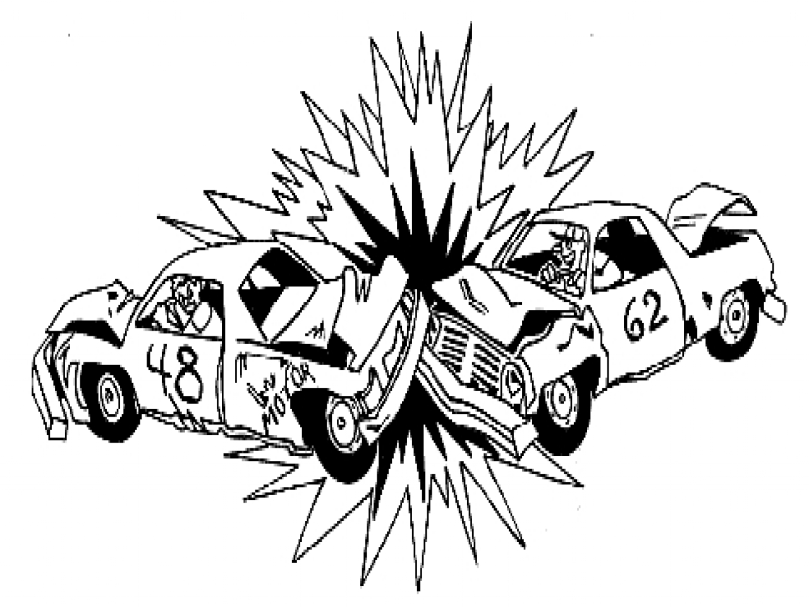

- The demarcation (fencing) between the demolition derby ring and the showground boundary (spectators) to be a minimum distance of 20 metres.
- Provide the insurer with details of the kind of safety fencing in place to protect the public.
- Confirmation the performance area is flat ie no jumps or risers permitted.
- All drivers must be 17 years or over and hold a current drivers licence – P Plate minimum.
- All drivers enter at their own risk and must read, understand and sign the appropriate Show Waiver form. This is to be signed before the commencement of the race and witnessed by a member of the Show Committee. Drivers should present themselves to the Show office at least 4 hours before the event to sign the documentation and get any updates about the event.
- Cars will be scrutinised on the day of the event. Failure to comply with the rules and regulations of the event may result in disqualification.

THE VEHICLES
- All cars must be of average sedan size. Station wagons, utes and panel vans are permitted to compete. Special dispensation to allow V8’s should be sought from the insurer. However, four wheel drives and full chassis vehicles are NOT permitted in the competition. All-wheel drive vehicles should have the four-wheel drive disconnected to make the vehicle a two-wheel drive.
- The vehicle must be retained at its original height, ie no alteration to the suspension.
- Scrutineers have the authority to inspect all competing vehicles and enforce rules and regulations.
- No driver under the influence of alcohol or drugs will be allowed to compete. Random Drug and alcohol testing may occur prior to commencement of the event.
- No passengers will be permitted to travel in the vehicle.
- No internal or external reinforcement or bar work allowed with the exception of a pillar bar. This should be either:
- A vertical steel bar be fastened to the floor and roof by bolts in the centre of the car or behind the driver’s seat in such a way as to allow the driver’s headrest to be fitted. OR
- Side to side pillar bar (minimum 10ml thick steel). OR
- A-frame top to bottom pillar bar (minimum 10ml thick steel).

- Bracing of the driver’s door mandatory. Either:
- A minimum of a single brace across the driver’s door. Must extend past the A and B pillar by 200ml. OR
- Reinforced skin on the inside driver’s door. OR
- Open door, weld across A – B pillar. Fully welded both sides. 300-400 ml apart. Mark inside skin of door. Door closes. Doors are fully welded.

- Driver’s door can also be filled with sand (NO concrete).
- All glass and plastic must be removed from the vehicle including glove box lid and airbags removed. Dashboard (dashboard plastic) should remain in place as well as an interior rear-vision mirror are permitted.
- All doors, bonnets and boots must be strapped or chained closed but accessible for scrutineering. Strapping to be welded using 1” x ¼” metal strapping or chains to be chained closed.
- All drivers must wear crash helmets, full cotton overalls and steel capped footwear. Gloves are optional.
- All drivers are to wear a seat belt. Seat belts must be in good condition. The vehicle must not contain rust in either the seat or seat belt mountings. Racing harness not permitted.
- An approved boat fuel tank or Gerry can with breather must be fastened in the centre rear in a cradle, where the back seat was.
- A maximum of ten (5) litres of petrol in the fuel tank is permitted.
- The vehicle’s petrol tank must be removed or punctured with a minimum ½” hole.
- The original specification fuel line must be used or alternatively maintain original fuel line route as close as possible to fuel cell. The object of this rule is to use as much of the original fuel line as possible. Any adaptions made should use original specification grade fuel lines and clamps and grommets when it passes through the body. Rubber grommets should be used.
- Tow bar and tongue must be removed.
- Mud guards and wheel arches must not be cut away or bent. Subject to scrutineer’s approval.
- Front wheel drive cars must only have standard car tyres. Where possible, standard car tyres should be used. At the show’s discretion whether winter tread or rally type tyres on rear wheel drive vehicles are permitted. Strictly NO tractor tyres permitted.
- The battery must be in a cradle and be securely bolted or welded in place and have a rubber cover fitted. It may be fitted to the cabin area and cable must have grommets where it passes through the firewall.
- The radiator should be in its original position but the fan blades may be removed (optional rule at Show’s discretion).
- Vehicles are NOT required to be fitted with a muffler (optional rule at Show’s discretion).
- The driver’s name must be displayed on the right hand side of the roof (150mm) (optional rule at Show’s discretion)
- Driver’s door should be white or red with the opposite colour painted in a cross on the door (optional rule at Show’s discretion).
- Each vehicle is to be numbered. The number is to be displayed only on the roof, bonnet or doors. Numbers will be allocated to cars at the time of receipt of nomination (optional rule at Show’s discretion)
- No Tek screws are to be used in any part of the vehicle.
- Brittle metal, such as grader blades, must not be used.
- Steel mesh must be welded on the driver’s half windscreen. No mesh to be welded on the driver’s side window.

IN THE RING
- An area will be marked on the Arena to show the boundary. Any vehicles driving over the boundary may be eliminated (Scrutineer’s/Judges decision).
- Any vehicle deliberately ramming the driver’s side door of another vehicle will be disqualified.
- Reverse gear must be used at all times, except when drivers need to dislodge from a competitor’s vehicle. In this case, first gear may be used for two (2) car lengths (optional rule at Show’s discretion).
- If a vehicle stops, a maximum of two minutes will be permitted to restart the vehicle. If the vehicle does not restart within this time, the vehicle will be eliminated (optional rule at Show’s discretion).
- Each driver shall have a white flag (30cm x 30cm) attached to a piece of dowel. A surrender flag is to be attached above the driver’s door and be accessible to the driver. When a driver wishes to surrender, they should snap the flag off. Driver’s doing this cannot re-enter the event.
- No vehicle is permitted to hit a surrendered vehicle or a vehicle out of bounds.
- All drivers must remain in their vehicle until the event is completed or as otherwise instructed by relevant safety crews.
- The winner of the competition will be the last vehicle still being driven.
- The Judge reserves the right to disqualify any driver at any time.
- The Judge’s decision is final and no correspondence will be entered into.

AFTER THE DERBY
- All cars must be trucked into and out of the Showground. All vehicles must be removed from the Showground following the completion of the event unless otherwise arranged with the Show Committee. Failure to do so may result in a fine.
- At the completion of the event a full sweep of the performance area needs to be done to clear any debris.

