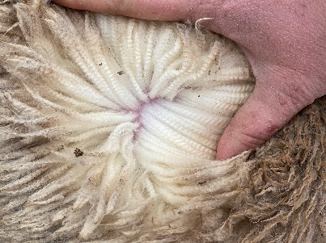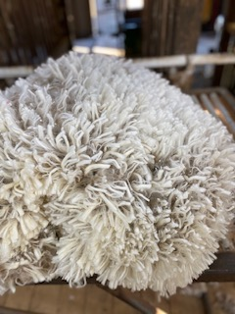

***Moree Show 2024***

***Wool Schedule***

**Sponsors:**

**Schute Bell Badgery Lumby**

**Millstead Scanning and Lambmarking**

**Turner Family**

**Damien and Sam Meppem**

**Pat and Chris Dillon**

**Pitman & Deakin**

**Ros O’Neill**

**Kendall family (Vicky Smith)**

**Nutrien Moree**

**STEWARD: Maddie Gough 0419256808**

**JUDGE: Ian Goddard**

**SUPREME CHAMPION FLEECE OF THE SHOW:** Sponsored by Nutrien Moree

**BEST COMMERCAIL FINE WOOL FLEECE:** Sponsored by the Turner Family

**BEST COMMERCIAL MEDIUM WOOL FLEECE**: Sponsored by Ros O’Neill

**BEST COMMERCIAL STRONG WOOL FLEECE:** Sponsored by the Kendall family

**BEST COMMERCIAL LAMB'S FLEECE (FINE, MEDIUM, STRONG):** Sponsored by Schute Bell and D&S Meppem

**BEST COMMERCIAL HOGGETT FLEECE (FINE, MEDIUM, STRONG):** Sponsored by Schute Bell and D&S Meppem

**6-8 MONTHS FLEECE:** Sponsored by Pat and Chris Dillon

**BEST PAIR OF COMMERCAIL GROWN FLEECES:** sponsored by Pitman and Deakin

**BEST PAIR OF COMMERCIAL LAMB OR HOGGET FLEECE:** Sponsored by Millstead Scanning and Lambmarking

**COMMERCIAL VALUE FLEECE:** Sponsored by Pitman and Deakin

**Fleeces to be delivered to Pitman & Deakin or the show office by 5pm Wednesday 24th April**

**Judging will commence by 8am Thursday 25th April.**

**Fleeces will be displayed in the Hobson pavilion**