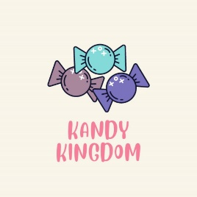
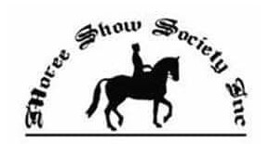
2022 MOREE SHOW COLOURING COMPETITION

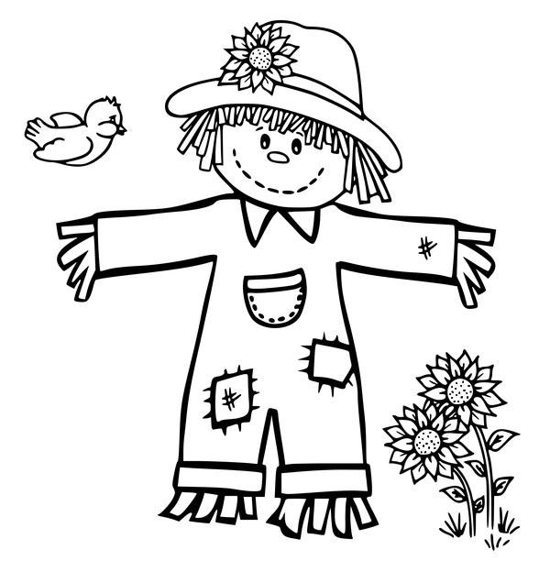

Name:…………………………………………………….. Age:…………………
Entries to be dropped to secretary’s office at the show grounds no later than 2pm Wednesday 20th.
Proudly sponsored by Kandy Kingdom, 17/30 Heber St MOREE 2400

