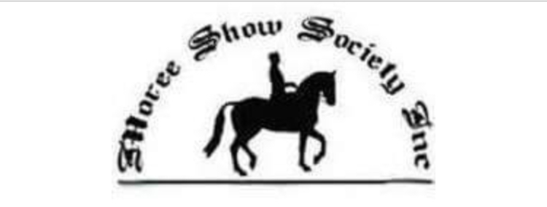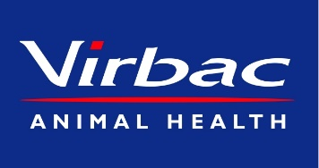
Gwydir Valley Championships Yard Dog Trial
Affiliated with the NSW Yard Dog Assoc. Inc
Stewards- Damien Meppem 0439190923
wilwurkkelpies@gmail.com
Saturday 27th April 2024
Judge Talk 8am
Trial Starts 8.15am
Tycannah Open Entry Fee $15 – Sponsored by the Gall Family “Tycannah” and Virbac Animal Health. Five Places receive prizemoney and ribbons.
At completion of OPEN
Truro Whiteface Maiden Entry Fee $10- Sponsored by The Hann Family- Truro Whiteface Bellata. Five Places receive prizemoney and ribbons.
At approx.. 4pm
D and S Meppem Livestock Services Encourage Entry Fee $8- Sponsored by D and S Meppem. Five Places receive prizemoney and ribbons.
Woods Airconditioning Ladies Entry Fee $7- Sponsored by Woods Air Conditioning Moree. Five Places receive prizemoney and ribbons.
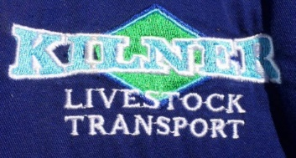

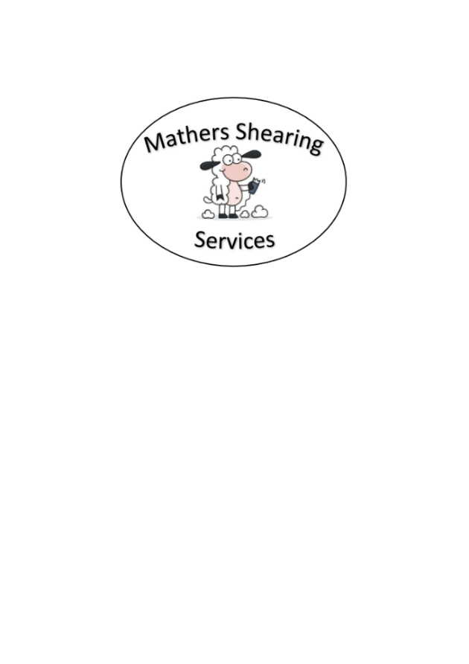
Sunday 28th April 2024
7:00am start
Complete Maiden if necessary then
Mather Shearing Services Novice Entry Fee $12 - Sponsored by Mather Shearing Services. Five Places receive prizemoney and ribbons.

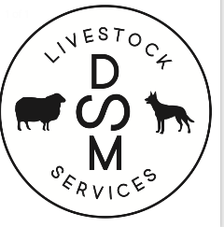
Entries Close: Wednesday 24th April 2024
- Entrys via Phone/text or email
- Ladies starting at approx. 4pm Saturday
- No late entries if program is full by closing date.
- Breakfast and Lunch available Sunday for competitiors and visitors.
- Committee reserves the right to alter the program if necessary.
- Run under NSW Yard Dog Assoc Rules
- All competitors receive a bag of dog biscuits thanks to Landmark Moree
- Maiden and Novice may be combined due to time restraints.
- Please ensure all dogs hold current vaccination certificates.
- Camping available $10/night- Please pay at office

We Thank Our Valued Sponsors
The Gall Family “Tycannah” Moree Virbac Animal Health Truro Witeface
Williams Stock Property and Water D and S Meppem Livestock Services Gwydir CaraPArk
South Moree Butchery Bayer Animal Health Mackay Earthmoving
Kilner Transport Mather Shearing Services
Nutrien Moree Woods Air Conditioning and Electrical

