TUG OF WAR CHALLENGE

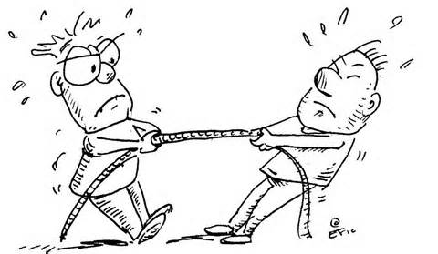
Join in all the fun at the Show and watch our teams compete in the Tug of War Challenge, just before the Fireworks on Saturday night
Mixed Teams of 8. Teams must have at least 2 women.
Entry $80 per team. Limited numbers. Waiver forms must be signed.
Enter at Secretary’s office before 3 pm on Saturday, 22nd, or email entries to moreeshow@live.com.au
Rules will apply. 1st prize $400 2nd prize $200
Total team weight must not exceed 800kg
Brought to you by

