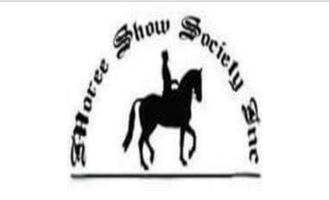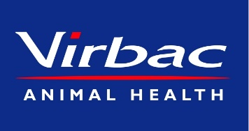
Gwydir Valley Championships Yard Dog Trial
Affiliated with the NSW yard Dog Assoc. Inc
Steward- Damien Meppem 0439190923
wilwurkkelpies@gmail.com
Saturday 23rd April 2022
Judge Talk 8am
Trial Starts 8.15am
Tycannah Open Entry Fee $15 – Sponsored by the Gall Family “Tycannah” and Virbac Animal Health. Five Places receive prizemoney and ribbons.
At completion of OPEN
Mungindi Wools Maiden Entry Fee $10- Sponsored by The Horton Family – Mungindi Wools. Five Places receive prizemoney and ribbons.
At approx.. 4pm
D and S Meppem Livestock Services Encourage Entry Fee $8- Sponsored by D and S Meppem. Five Places receive prizemoney and ribbons.
Woods Airconditioning Ladies Entry Fee $7- Sponsored by Woods Air conditioning Moree. Five Places receive prizemoney and ribbons.

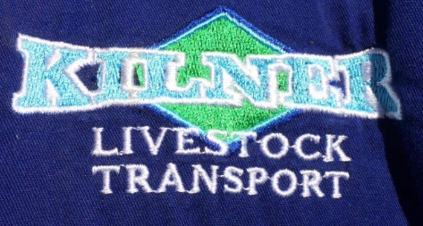

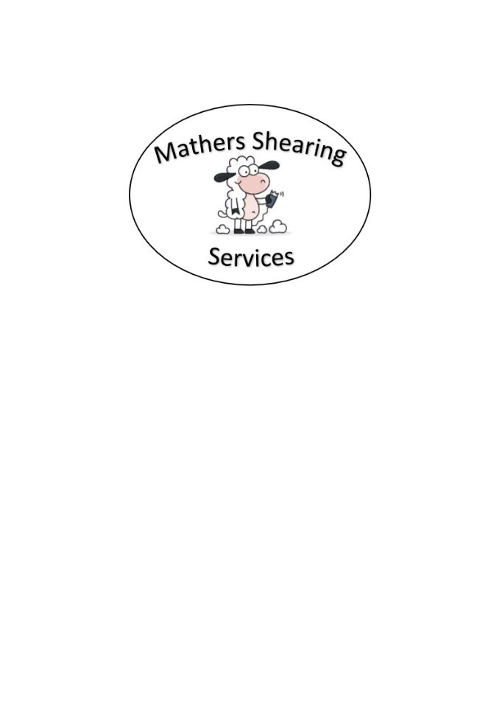
Sunday 24th April 2022
7:00am start
Complete Maiden if necessary, then
Mather Shearing Services Novice Entry Fee $12 - Sponsored by Mather Shearing Services. Five Places receive prizemoney and ribbons.

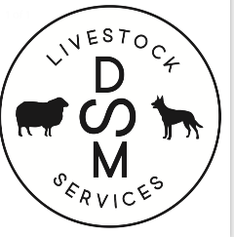
Entries Close: Wednesday 21st April 2022
- Entries via Phone/text or email
- Ladies starting at approx. 4pm Saturday
- No late entries if program is full by closing date.
- Breakfast and Lunch available Sunday for competitors and visitors.
- Committee reserves the right to alter the program if necessary.
- Run under NSW Yard Dog Assoc Rules
- All competitors receive a bag of dog biscuits thanks to Nutrien Ag Moree
- Maiden and Novice may be combined due to time restraints with Anzac Day ceremonies.
- Please ensure all dogs hold current vaccination certificates.

We Thank Our Valued Sponsors
The Gall Family “Tycannah” Moree Virbac Animal Health Mungindi Wools
Williams Stock Property and Water D and S Meppem Livestock Services Gwydir Carapark
Bayer Animal Health Compressed Light and Power Kilner Transport
Mather Shearing Services Tyrone Pastoral Co Woods Air Conditioning and Electrical

